Kevin Chrzanowski

Remo Assignment #2

2. PBM, or protein binding microarray, is a binding assay that allows the determination of a protein’s function on a large scale. A protein of interest is placed on a nitrocellulose slide in large quantity and then a reagent is used to make sure that the protein doesn’t denature and is able to bind to a specific substance attached to the slide such as a specific DNA sequence. Then a secondary antibody attached to a fluorescent bead is injected into the solution with the microarray. The antibody binds to its target protein in a specific area and leaves a fluorescent mark when it has bound its target. Those proteins with a mark are then assumed to have binding affinity for the substance on the slide.

SELEX-seq works a bit in reverse of PBM. In SELEX-seq, a protein is immobilized on a slide and a series of different oligonucleotides are released. After the oligonucleotides are given a chance to bind to the proteins, any unbounded oligonucleotides are washed away and then the bound sequences are amplified and sequences.

ChIP-seq is useful in removing DNA bound by a protein when it is extracted from a cell. When a cell’s DNA is lysed and separated from the other cellular components, it is sonicated to break it up into several smaller pieces. Then antibodies attached to immunoprecipitant beads are used to bind to the proteins and the proteins are precipitated out of solution. The proteins are then removed from their bound DNA and the DNA sequences they were bound to are sequenced. ChIP-seq requires that proteins don’t become denatured but are useful in finding the sequence of several oligonucleotides that are protein bound.

PBM and SELEX-seq are in many ways quite similar. They both are searching for a target DNA sequence but the substance that is attached to the slide is different in both procedures. In PBM, it is DNA that is attached to the slide and protein that is released in solution, while the molecules are reversed for SELEX-seq. A disadvantage of PBM is that it requires a known antibody to a target protein before it can be used, while SELEX-seq can be can be more costly.

4.

|  |  |  |
| --- | --- | --- |
| Type of -mer | File Source | Average R2 |
| 1-mer | Mad | 0.68788 |
| 1-mer + 1-shape | Mad | 0.56768 |
| 1-mer | Max | 0.70286 |
| 1-mer + 1-shape | Max | 0.51139 |
| 1-mer | Myc | 0.72717 |
| 1-mer + 1-shape | Myc | 0.56523 |

For each row, there were 31-33 values of R2 that were averaged.

5.

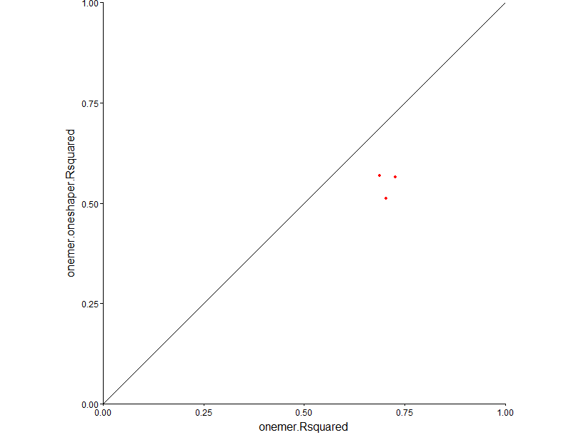

From left to right, the three data points represent data from Myc, Mad, and the Max datasets respectively. The straight line is a 45 degree angle line for which the x-coordinate is equal to the y-coordinate. The fact that all three points are below the line indicates that the r2values for the 1-mer are greater than the ones for the 1-mer+ 1-shaper. This finding is a bit unusual because generally the 1-mer+1-shaper has a greater value than just the 1-mer. This is because the former typically having more explanatory power than the latter due to the additional binding information given by the DNA shape.

Rather, in this case the DNA shape information must have expanded the range of parameter estimates and thus weakened the r2 value.

7. The biggest difference between the plotShape of the bound DNA and the unbound DNA is that the bound DNA parameters are all about a bell curve distribution while the unbound ones are similar to horizontal lines. This means that the bound DNA converges to a central value for all 4 parameters, albeit an inverted bell curve for the HelT value. This indicates that being bound by a protein can induce DNA to take up some optimal shapes

The unbound DNA does not converge to any central values for any of the shape parameters. That means there is no optimal parameter for the unbound DNA to take..